

**GENC CAPSTONE -**

**FINAL PROJECT**

DONE BY : Induja D

EMP ID: 2319849

COH ID: CSDAIA24AZ003

**Problem Statement:**

Fetch data from source URL & load in raw layer as zip file, unzip files into refined container which is staging layer and processed or clean data that has been arrived in last 24 hrs from source & load into ADLS processed container in parquet file as delta table.

**Requirements 1 - Data Preparation (use ADF):**

**1. Fetching and Loading Raw Data:**

* The source data will be fetched from the provided URL: [SalesOrderHeader.csv](https://raw.githubusercontent.com/microsoft/sql-server-samples/master/samples/databases/adventure-works/oltp-install-script/SalesOrderHeader.csv) and one zip file is uploaded manually.
* The fetched data will be loaded into the raw container in ADLS in zip file format.

**2. Unzipping and Loading Data into Staging:**

* Unzip the files that have arrived in the last 24 hours from the source.
* Load the unzipped files into the ADLS refine container in the path: refine/<participant_name>/Unzippeddata/file.

**3. Processing and Loading Clean Data:**

* Process or clean the data from the unzipped files using Azure Databricks (ADB).
* Load the processed or clean data under the processed container using either Azure Databricks or Azure Data Factory (ADF) in the form of parquet files.

**Requirements 2 - Data Transformation (use ADB):**

**1. Accessing Data Lake using Secret Keys:**

* Access the data lake using secret keys by creating secrets in Key Vault.

**2. Adding Header to Raw File:**

* Add headers to the raw file "sourceorderheader" with the provided schema:

SalesOrderID,RevisionNumber,OrderDate,DueDate,ShipDate,Status,OnlineOrderFlag,SalesOrderNumber,PurchaseOrderNumber,AccountNumber,CustomerID,ShipToAddressID,BillToAddressID,ShipMethod,CreditCardApprovalCode,SubTotal,TaxAmt,Freight,TotalDue,Comment,rowguid,ModifiedDate.

**3. Joining and Cleaning Data:**

* Join the "product" file and "salesorderdetails" file.
* Perform necessary cleaning:
  + Drop all entries where color is null.
  + Check the difference between StandardCost and ListPrice for each sales order.
  + Replace product sizes: S -> 30, M -> 32, L -> 34, XL -> 36, XXL -> 38 to display available product groups by size.

**4. Creating Managed Delta Tables:**

* Create managed delta tables in Azure Databricks for performing analysis using SQL queries.

**5. Creating External Delta Tables:**

* Create external delta tables in Azure Databricks and load data in the form of parquet files into the processed data lake container.

**Setup Email Configuration:**

* Configure email notifications for pipeline failure and success.
* The email should contain pipeline name, run ID, and failure/success message.

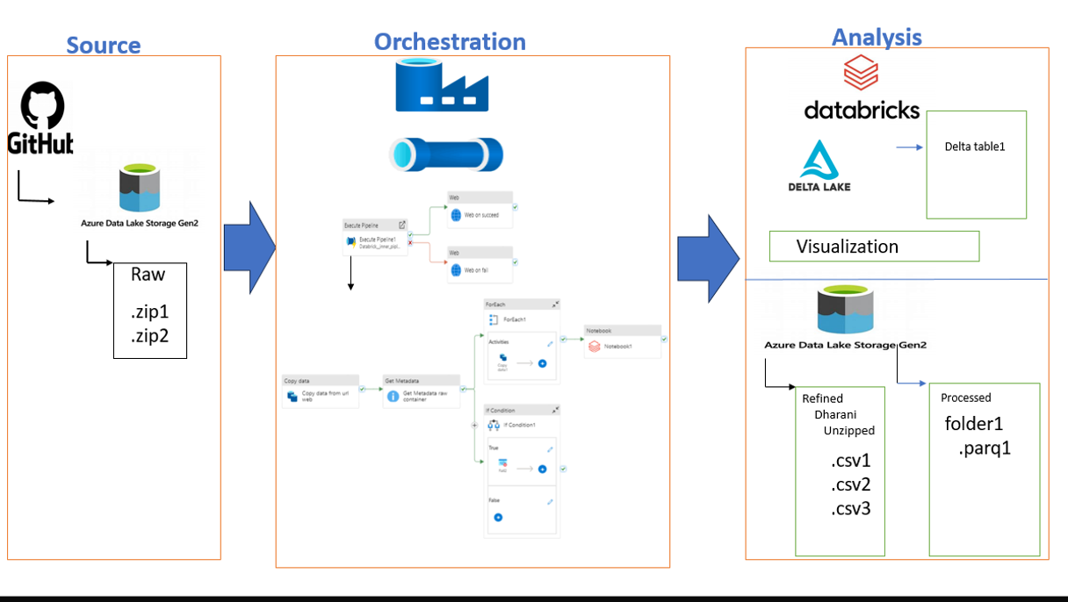

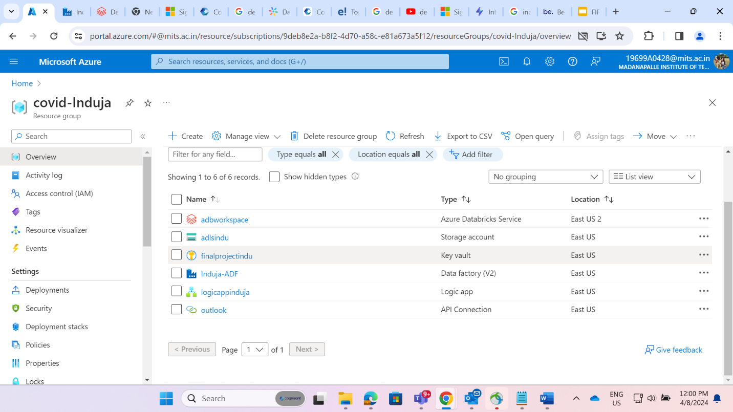

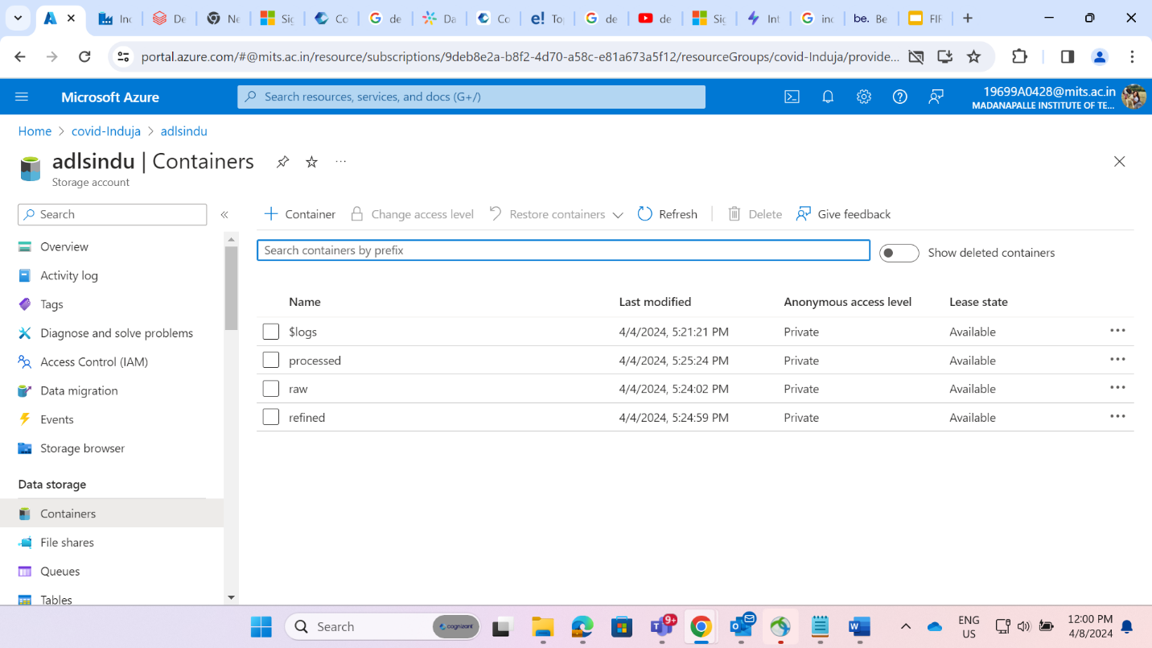

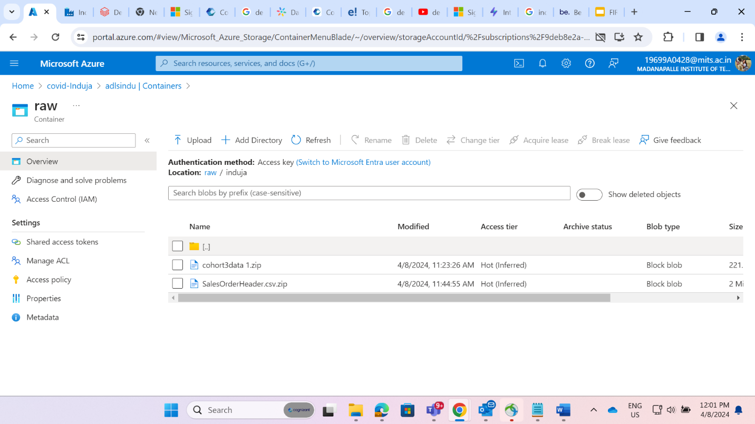

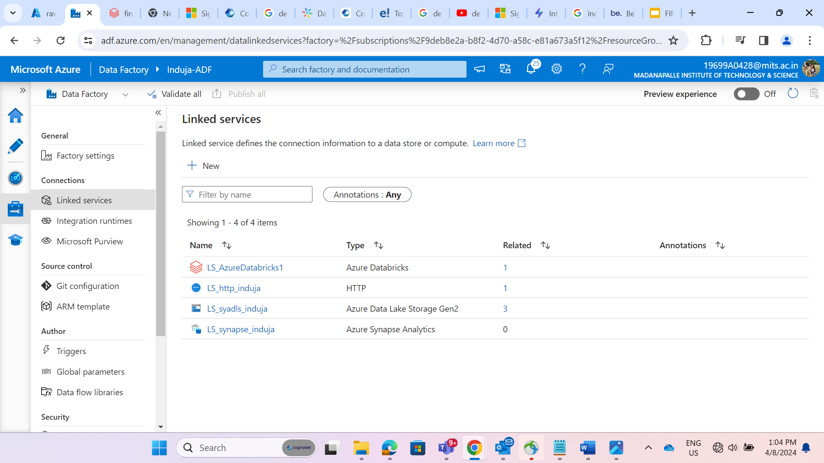

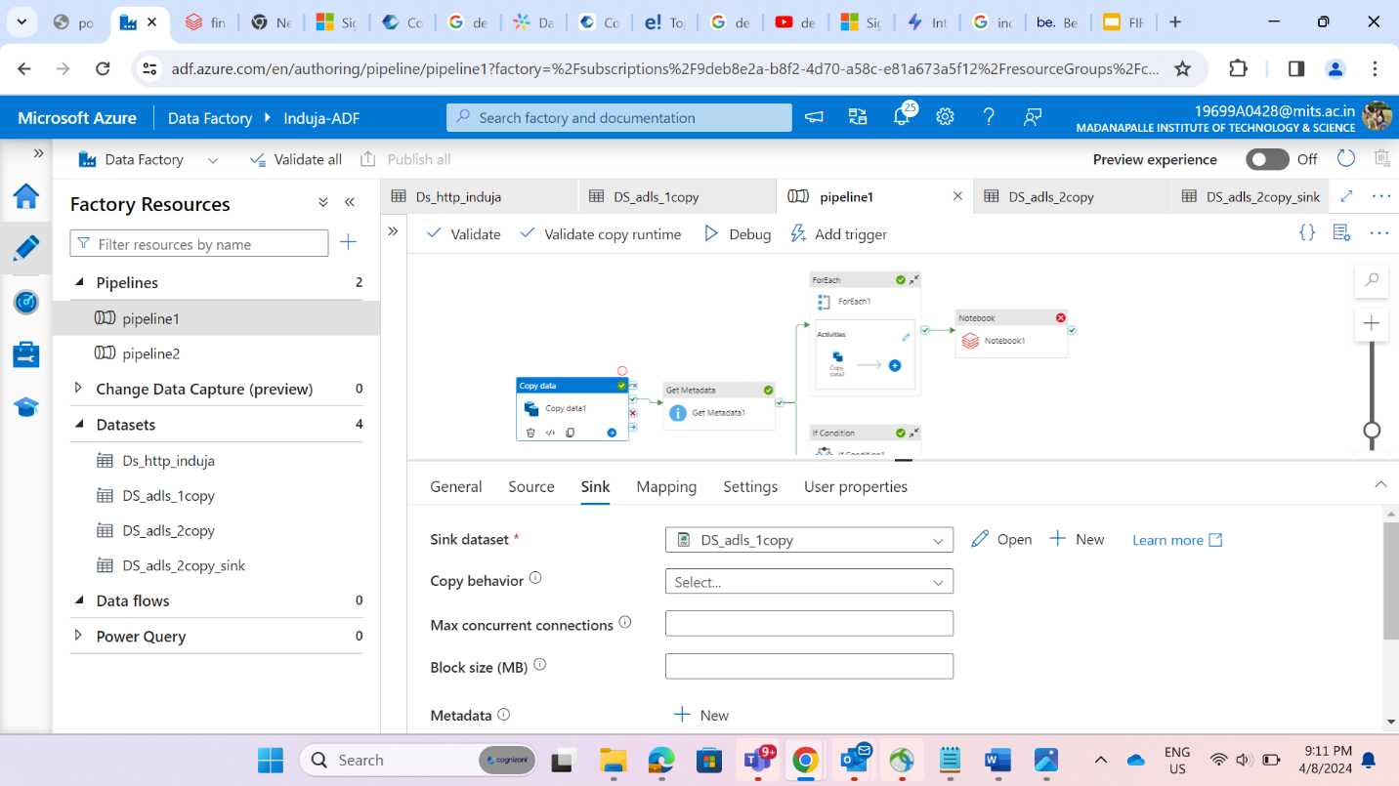

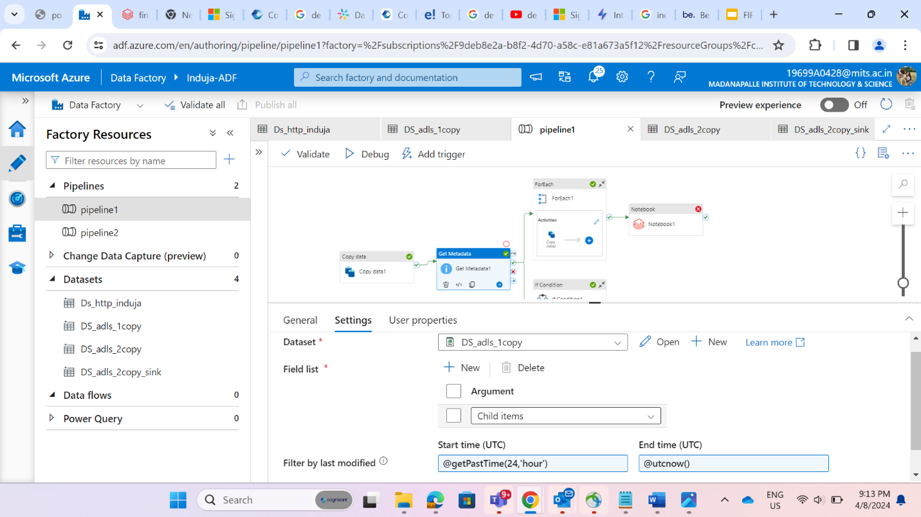

@activity('Get Metadata1').output.childItems

